**Big Table Top (version: 20150412)**

**Robot Size limit** : 18 x 18 inches

**Robot Weight Limit** : 5 pounds

|  |  |
| --- | --- |
| **Robot Control** | : Autonomous |
| **Game Duration** | : 7 minutes |
| **Arena** | : 60 x 72 inches |

**Overview:**

The field is setup with 5 empty soda cans wrapped in fluorescent orange duct tape randomly placed on top of a table. Robots must locate the cans and complete a series of objectives with them. The table top has no edge protection so robots must take measures to avoid falling off.

**Objectives:**

1. Knock a can off the table
2. Place a can in a box hung off the edge of the table at a specific location (see diagram) 3) Return a can to the starting location.
3. The whole can must be within the starting area
   1. Touching the boundary but not extending beyond the boundary is considered “within”
4. Line 2 more cans up with the can in the starting location
   1. The outer cans cannot be farther than 36 inches from each other
   2. Cans must be at least 8 inches apart
   3. A one inch wide yardstick must be able to lay across all 3 cans

**Game Play:**

1. Each competitor is allowed three runs.
2. A run starts when the robot leaves the starting area and ends when the four challenges are completed, the robot falls from the table or the time limit is reached.
3. The objectives can be executed in any order. Any of the available cans can be used for any challenge.
4. Robots should be designed to survive falling off a table

**Scoring:** (Max possible score of 5)

* 1 Point for each can in a completed objective
* In case of a tie, the judge will determine the winner by taking into consideration the robot build and the ingenuity of how the objectives were completed.

**Judging:**

The contest will have one or more judges. They will ensure the rules are followed and remove a robot from competition if the robot is operating in an unsafe manner. All judges’ decisions are final.

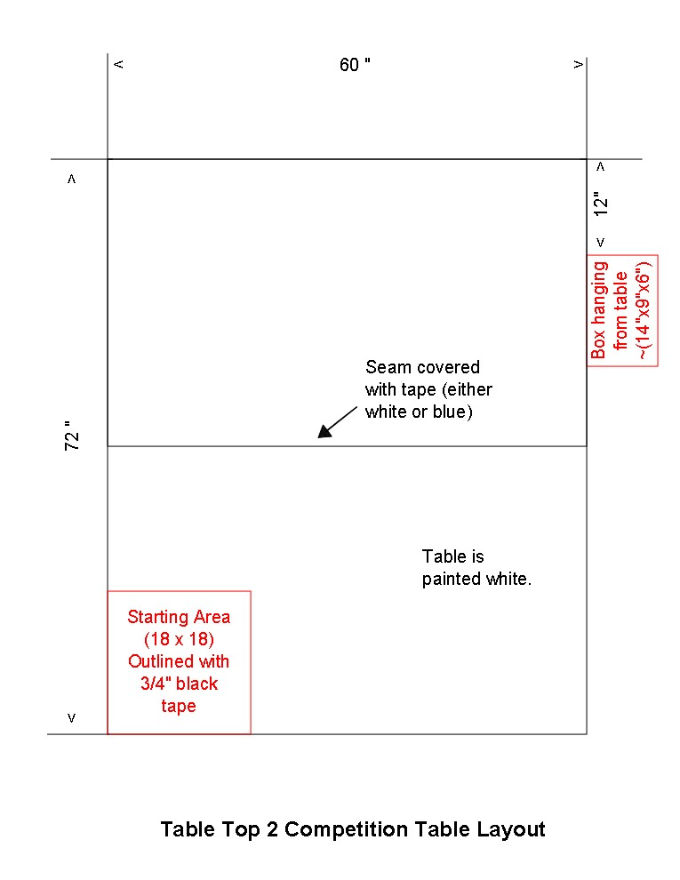

**Course:**

1. Dimensions: 60 x 72 inches
2. Table Material: 2 pieces of plywood painted white (~36 inches x 60 inches)
   1. There is a seam that runs between the center of the narrow sides of the platform
   2. This seam is covered by white or blue tape 3) Starting Area:
   3. 18 x 18 inches
   4. Marked by ¾ black electrical tape or black paint (outer edge of tape at 18”)
   5. Black tape is used to only outline edges of starting area that are not table edges
   6. The black tape is part of the start area 4) Drop Box:
   7. 14 x 9 x 6 inches (size of large shoe box)
   8. Located at the opposite corner of the starting area
   9. 12 inches from the end of the table
   10. 14 inch side of box is along the 72 inch side of the table
   11. See diagram for layout details

A practice Big Table Top will be available at DPRG's RBNO held every Tuesday before the competition.

**Can Specifications:**

1. Standard 12 ounce aluminum soda cans
2. Wrapped in 1 to 2 layers of fluorescent orange duct tape
   1. Duck Brand Model #1265019 Neon Colored Duct Tape
   2. Available at Walmart, Home Depot, Staples, and Amazon
3. Pull tabs may or may not be removed

**Safety:**

Since robots could sustain a 3 foot fall, it is recommended that robots weigh less than one pound. If a robot is deemed "unsafe" it will not be allowed to participate. Participants can use "leashes" (rope, string, etc. tied to robot) but their use would result in a 1 point penalty.

**Acknowledgment:**

This contest is a greatly modified version of a competition originated by the Home Brew Robotics Club and found on [www.robogames.net.](http://www.robogames.net/)